BFA AUGUST Social
Wednesday the 26th of August 2026
Town Bar, Queensgate from 1-4pm
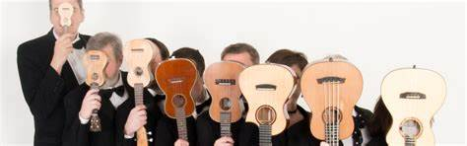
The Jolly Rogers Ukulele Band
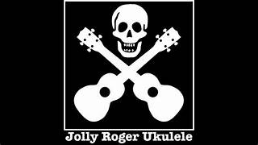
Come and hear the return of this fabulous band at our BFA Social led by Alan Hart.
The ukulele is a versatile instrument from Hawaii, it has gained global acclaim for its melodic contribution to music. Its charm brings a unique sound to a myriad of musical genres.

There will also be a Raffle and BFA Information Available on the day. Entrance is £1
Bar will be open selling refreshments

