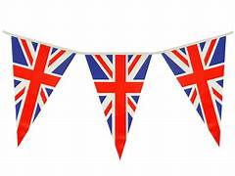
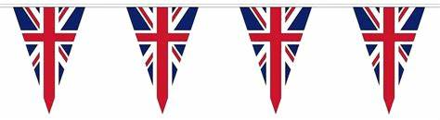
BFA Summer Community Party
Wednesday 22nd of July 2026 1-4pm
Town Bar, Queensgate (Bridlington Football Ground)
Entrance: £2pp (Which includes a Slice of Cream Cake!) Children Free, No Dogs
Celebrating Music from the 1940s Wartime & Beyond
BFA Afternoon Entertainment: The Vintage Vocalist
Come along and listen to the fabulous Paula Marie as she takes us on nostalgic trip!

The Bunting will be up, the Bar will be open, including the Tea and Coffee Station to purchase refreshments (Free Kiddie Craft Table)
For More Information please contact Tracey via: E: chairbfa@mail.com or
Tel: 07935 980159
The Mayor and their Consort will also be attending as Special Guests, plus some other Special Guests from our Local Community.
Please feel free to invite your friends and family along to share in this very special concert. Paula Marie is the ‘Darling’ of BFA and launched our BFA Charity with Us.

