BFA Strolling Group

Fancy some Fresh Air in Good Company
This group meets once a month at various locations to have a leisurely stroll around a place of interest or along a Seafront and then finish with Coffee and Cake/Lunch at or near the location.
The 19th BFA Strolling Group will take place in Bridlington, on Tuesday the 22nd of September 2026 at 11am onwards.

Bruce will meet you just before 11am at Bridlington Railway Station (RS). The walk will start from the RS via Quay Rd over the railway tracks, left at Roundabout over the Railway Bridge, Along the ‘New Walk’ (by B&M etc). The Group will stop at Cooplands Café for refreshments, then continue and cut down Springfield Avenue then back around to Bridlington Railway Station.

This BFA Strolling Group location is suitable for people with Mobility Issues and those who use a Wheelchair or Mobility Scooter. There are plenty of places to sit dotted along the way. It’s a great way to stroll with others and enjoy Beautiful Bridlington.
Bruce and the BFA Committee are always present and look forward to seeing YOU!
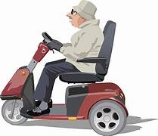
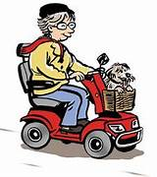
For more information contact Bruce:07882 305832

