BFA Strolling Group

Fancy some Fresh Air in Good Company
This group meets once a month at various locations to have a leisurely stroll around a place of interest or along a Seafront and then finish with Coffee and Cake/Lunch at or near the location.
The 20th BFA Strolling Group will take place in Bridlington, on Tuesday the 20th of October at 11am onwards.

Bruce will meet you just before 11am, at East Riding Leisure Centre (beach side) from there we will have a stroll along to and around the harbour, watch the fishing boats, then onto South Beach, stopping at Richie’s Café for refreshments, then do the reverse journey back.

This BFA Strolling Group location is suitable for people with Mobility Issues and those who use a Wheelchair or Mobility Scooter. There are plenty of places to sit dotted along the way. It’s a great way to stroll with others and enjoy Beautiful Bridlington.
There is plenty of parking at the leisure centre and in the surrounding roads. The walk is just short of 2 miles in total
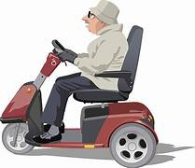
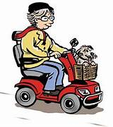
The BFA Committee are always present and look
forward to seeing YOU!
For more information contact Bruce:07882 305832

