BFA Monthly Social
When: Wednesday 23rd of September
Where: Town Bar, Queensgate, Bridlington
Time: 1-4pm
History of the Chalk Tower
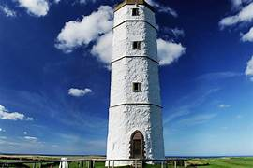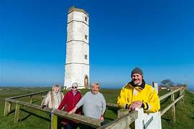
Speaker: Chrys Mellor
Chrys is part of Friends of the Chalk Tower
Flamborough Head (flaembara) is a promontory, 8 miles (13 km) long on the Yorkshire coast, between Filey and Bridlington bays. It is a chalk headland, with sheer white cliffs. The cliff top has two standing lighthouse towers, the Chalk Tower, dating from 1669 and Flamborough Head Lighthouse built in 1806. The older lighthouse was designated a Grade II* listed building in 1952 and is now recorded in the National Heritage List for England.
This promises to be a very interesting talk and a chance for us to learn about a very interesting landmark that we are all familiar with.
There will also be a Welcome Table, BFA information and a Raffle
The Bar and Tea & Coffee Station will be open serving
refreshments for you to purchase.
Entrance is £1 per person

