BFA Halloween Craft Café
When: Wednesday 14th October
Where: Town Bar, Queensgate, Bridlington
Time: 1-4pm
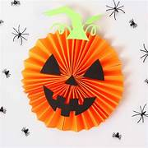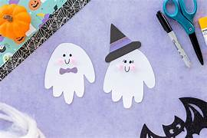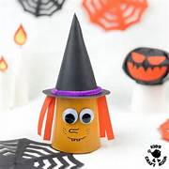
Come along and bring your craft project with you or have a go with a Craft on offer.
If crafting isnt for you then come along and have a Cuppa and Chat, listen to background music and laugh with us!
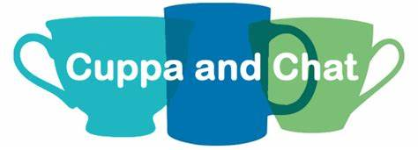
The bar will be open selling hot & cold refreshments
BFA Event Information available
Entrance £1

