BFA Halloween Community Concert
When: Wednesday the 28th of October
Where: Town Bar, Queensgate, Bridlington
Time: 1-4pm (Event: Open to the Community)
Entertainment: Mad 4 Mildred
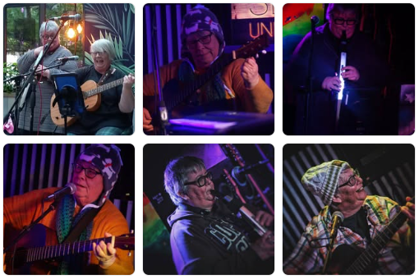
Mad 4 Mildred are the Yorkshire coasts only aerophone/acoustic duo (as far as we know). They play an eclectic mix of covers from all decades with a Mad 4 Mildred twist. BFA can’t wait to welcome Lorraine & Julie who have played many different venues and festivals.
There will also be a Raffle on the day, BFA Welcome table and BFA Information. The Bar will be open selling Hot & Cold Drinks. Free Kiddies Craft Table.
BFA Members Entrance is £1pp - Non-Members £2 pp - Children are Free

