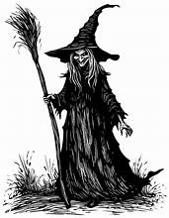
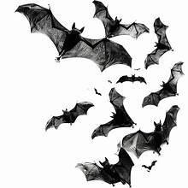
BFA Halloween Community Concert
When: Wednesday the 28th of October
Where: Town Bar, Queensgate, Bridlington
Time: 1-4pm (Event: Open to the Community)
Entertainment: Mad 4 Mildred
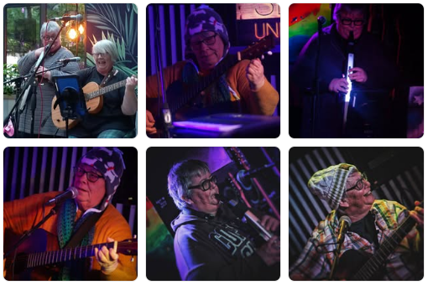
Mad 4 Mildred are the Yorkshire Coasts only aerophone/acoustic duo (as far as we know). They play an Eclectic Mix of covers from all decades with a Mad 4 Mildred twist
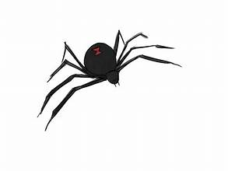
BFA can’t wait to welcome Lorraine & Julie who have played many different venues and festivals
There will also be a Cauldron Raffle and a BFA Welcome Table
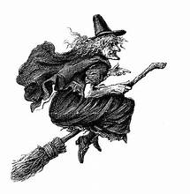
The Bar will be open selling Hot & Cold Drinks. Free Kiddies Craft Table

