BFA Friendship Café
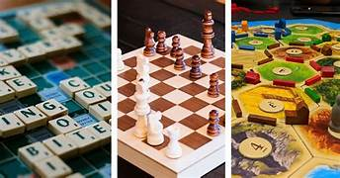
When: Wednesday 9th September
Where: Town Bar, Queensgate
Time: 1-4pm
Come along to this Friendship Café and sit and natter or play a Board Game or two like: Chess, Scrabble, Cards, Dominos etc

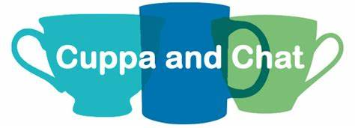

If Broad Games aren’t your thing, then come along and have a Cuppa and a Chat. There will be background music, conversation, lots of laughter, BFA information and chit-chat.
There will be Free Tea, Coffee and Bottled Water and the Bar will be open selling other refreshments.
Free Entrance

