BFA Friendship Café
Summer Beach Outing
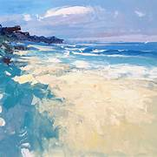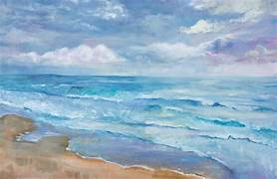
Let’s Enjoy an Afternoon at North Beach
Meet Us at the end of North Beach. In front of the beach huts and the café from 1pm-4pm On
Wednesday the 8th of July.
Bring your deckchairs, Blankets, beach umbrellas, bats & balls, Frisby’s, Towels, buckets & spades, picnics
(or buy something from the café)
There are also public toilets just behind the café.
Let’s enjoy a traditional beach visit in great company.
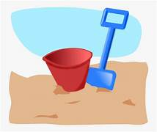
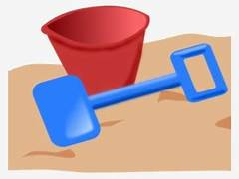
Paddling In the North Sea is for Our Brave Members! Don’t forget your Sunscreen & Knotted hankies!

