BFA Friendship Café
When: Wednesday August 12th
Where: Town Bar, Queensgate, Bridlington
Time: 1-4pm
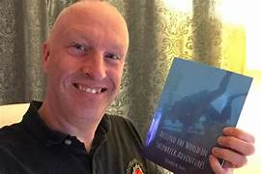

Speaker: Richard M Jones
This will be a brand-new talk by prolific local author Richard M Jones about his books in general, giving a great opportunity for Richard to talk about all the different projects and the challenges faced along the way.
Richard has written multiple books such as: The Titanic Fleet, The 50 Greatest Shipwrecks, Living the Dream, Serving the Queen, Lost at Sea in Mysterious Circumstances & Britian’s Lost Tragedy’s Uncovered etc.
Entrance is: £1 per person
Tea, Coffee & Bottled Water is Free
The Bar will be open serving other
refreshments for people to purchase
Welcome Table, BFA Information and BFA Committee
Present. More Info: chairbfa@mail.com T: 07935 980159

