BFA April Monthly Social
When: Wednesday the 22nd of April
Where: Town Bar, Queensgate, Bridlington
Time: 1pm-4pm
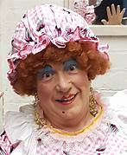
Speaker: Mike Hammond Bridlington Gold Radio Breakfast Show Presenter
Actor and Pantomime Dame!

Mike has had a fascinating life working in Radio, Television & Theatre and has agreed to come along and share some of those memories with us in a talk he aptly calls:
“Smoke and Mirrors”
Mike gets involved with and promotes many Events within our Community and has interviewed some very interesting people. This is one not to be missed.
Entrance £1, Raffle and BFA Information and Sign-Up Sheets for BFA Eatery Meals
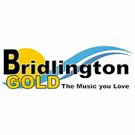
Town Bar will also be open selling Hot and Cold Refreshments
