BFA FEBRUARY Social
Wednesday the 25th of FEBRUARY 2026
Town Bar, Queensgate from 1-4pm
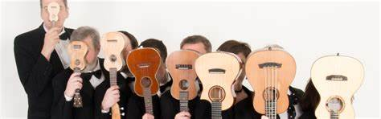
The Jolly Rogers Ukulele Band
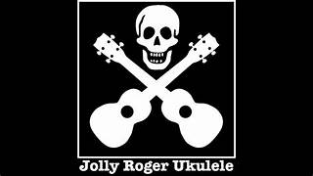
Come and hear this fabulous band at our BFA Social led by Alan Hart.
The ukulele is a versatile instrument from Hawaii, it has gained global acclaim for its melodic contribution to music. Its charm brings a unique sound to a myriad
of musical genres.
There will also be a Raffle and BFA Information Available on the day Entrance is £1
Bar will be open selling refreshments

