BFA Strolling Group

Fancy some Fresh Air in Good Company
This group meets once a month at various locations to have a leisurely stroll around a place of interest or along a Seafront and then finish with Coffee and Cake/Lunch at or near the location.
The 15th BFA Strolling Group will take place in Bridlington, on Tuesday the 19th of May 2026 at 11am onwards.

Bruce will meet you just before 11am, at the old Expanse Hotel, North Marine Drive, Bridlington. The Group will proceed to walk along North Beach Promenade to Harbour. Once the Group have spent time at the Harbour the Group will go to KoKo Café for Refreshments, then back along North Beach Promenade and back to the Expanse Hotel.

This BFA Strolling Group location is suitable for people with Mobility Issues and those who use a Wheelchair or Mobility Scooter. There are plenty of places to sit dotted along the way. It’s a great way to stroll with others and enjoy Beautiful Bridlington.
There is plenty of parking outside the Expanse Hotel, on the seafront and in the surrounding roads. The walk is approx. 2 miles in total.
Bruce and the BFA Committee are always present and look forward to seeing YOU!
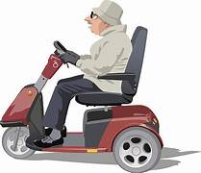
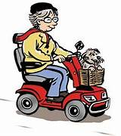
For more information contact Bruce:07882 305832

