BFA Community Easter Concert
When: Wednesday March 25th, 2026
Where: Town Bar, Queensgate, Bridlington
Time: 1-4pm
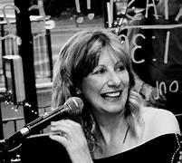
Entertainment: Jenny Bray
Jenny's music and live performances are often surrounded by a plethora of the UK's leading musicians, including saxophonist Rod Mason, bassist Richard Hammond, guitarist Jezz Platt and percussionist Dave Walsh. She's also worked closely with Grammy nominee Olive Joseph, an 'explosive' vocalist and original member of the Jenny Bray Band. Jenny recorded a fourth album in July 2025 at a Pennsylvania studio with members from her original US band.
This is an open Community Event please feel free to bring your Family & Friends
This is one not to be missed.
Entrance: £2 per person. Children Free
There will also be a Raffle, and the Bar will be open selling Hot and Cold Drinks

