BFA Friendship Café
Wednesday the 8th of April
Town Bar, Queensgate from 1-4pm
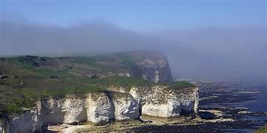
Speaker: Richard Myerscough
Flamborough FEAST Project
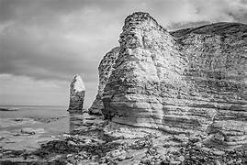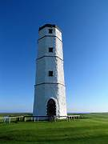
Richard runs a Geoarchaeology Group within our community and has worked on many projects such as the Geo Park and the Roman Villa excavation. This will be a very interesting talk.
Entrance is £1pp – Everyone Welcome

