BFA Friendship Café
Wednesday May the 13th
Town Bar, Queensgate from 1-4pm
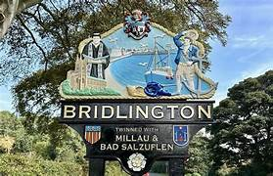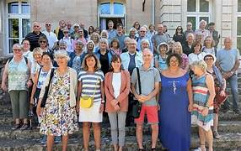
Speaker: Chris Myers
Subject: Bridlington Milliau Twinning Association
Bridlington and Millau have been twinned since 1991, and the Association offers members the chance to take part in a wide range of social events, meetings and trips
to our beautiful twin towns.
This promises to be a very interesting talk
£1 Entrance, Free Teas and Coffees
Town Bar is open serving other Refreshments
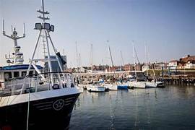
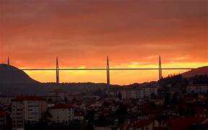
BFA Welcome Table & BFA Information available

