BFA Easter Craft Café
When: Wednesday the 11th of March 2026
Where: Town Bar, Queensgate, Bridlington
Time: 1-4pm

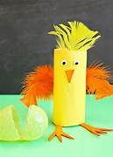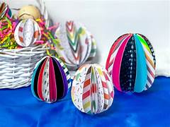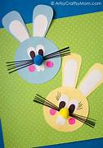
Come along and enjoy our Easter Crafts on Offer
You are very welcome to bring your own Craft Project and let others see your work.
There will be FREE Tea & Coffee, and the Bar will be Open
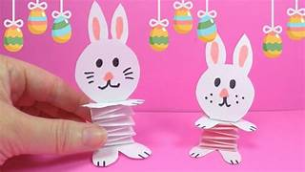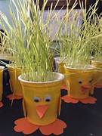
Or just pop in for a Cuppa and a Chat
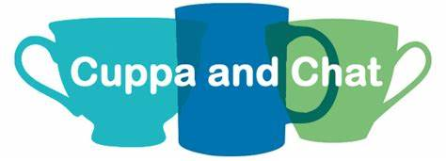
Entrance is £1 per person and Children are Free

