BFA Monthly Social
Wednesday the 27th of May 2026 1-4pm
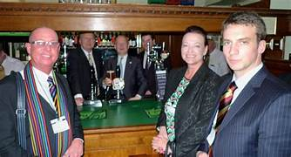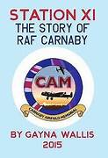
Speaker: Gayna Wallis
Topic: Carnaby Airfield Memorial
The Bridlington Augustinian Society
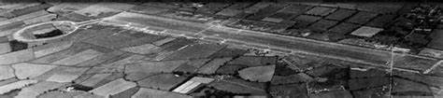
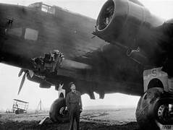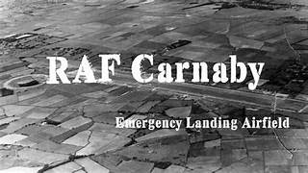
Gayna is a seasoned speaker and a:
We look forward to seeing you at the Town Bar, Queensgate, there will also be a Raffle on the Day, The Bar & Tea and Coffee Station will be open. Entrance is £1 per person
Published Author and Carnaby
Airfield Historian. The Comradery, Stories
and History attached to this airfield
is fascinating.

