2026 BFA Monthly Quiz Nights
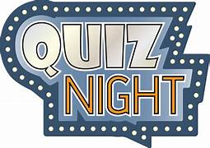
Come join the fun and laughter at the Town Bar, Queensgate 7pm for a 7.30 pm start
ALL WELCOME
All dates are the Last Thursday of the Month
THURS 29TH JAN | THURS 30TH JULY
THURS 26TH FEB | THURS 27TH AUG
THURS 26TH MARCH | THURS 24TH SEPT
THURS 30TH APRIL | THURS 29TH OCT
THURS 28TH MAY | THURS 26TH NOV
THURS 25TH JUNE | The December Mini Quiz is part of the BFA Christmas Social on WED 16th December
Everyone gets to play as part of a Team
Committee always present to Meet & Greet
8 Rounds of Questions with something for Everyone
Cash for Questions and a Raffle
Entrance is £2 per person with all entrance monies being paid out in Team Prizes

