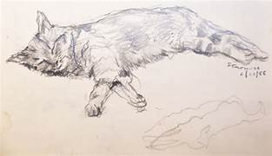
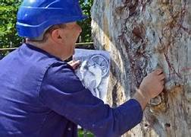
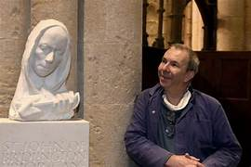

BFA Community Social
New Date: Wednesday the 10th of June 2026
Where: Town Bar, Queensgate, Bridlington
Time: 1pm – 4pm
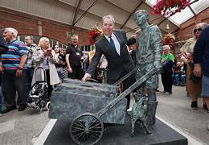
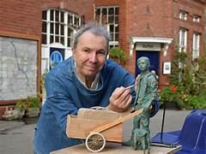
BFA are Proud to Announce a Local Celebrity Speaker:
Stephen Carvill
Sculptor
Designer

Artist
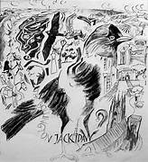
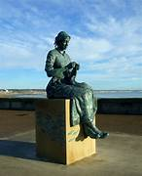
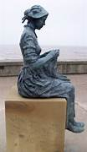
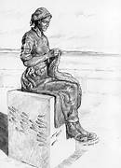

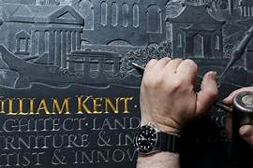
This is a very rare opportunity to hear
Stephen Carvill talking about his life and works.
This talk is one not to be missed.
Entrance £1 per person, Raffle, Bar Open
Welcome Table and BFA Information available.
Open to the Community to attend.

